CURATOR SOCIAL APP REPORT

INTRODUCTION
This social app is specifically designed to simulate the core features of modern social networking platforms. This app enables the users to interact, share content and build online communities allowing individuals to interact regardless of geographical barriers.
We chose the name curator because it’s an app where people don’t just post randomly. They select, organize, and share meaningful content
This report analyzes the Social App using a system design approach. The goal is to break down the application into its functional and non-functional components, evaluate its limitations, and propose scalable solutions.
The report follows five major steps:
Use Cases Generation
Constraints and Analysis
Basic Design
Bottlenecks
Scalability (Iterative Improvements)
This structured approach ensures a clear understanding of how the system works and how it can be improved.

1: Use Cases Generation
Use cases define how users interact with the system. The primary actors in this system are users (end-users) and system administrators.
Core Use Cases-1. User Registration & Login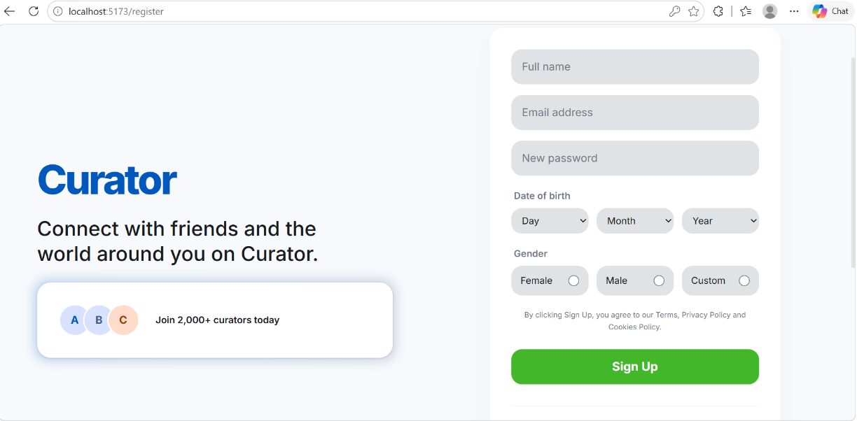
This is where the users create accounts using email or credentials.
Secure authentication ensures only authorized access.
2. Profile Management
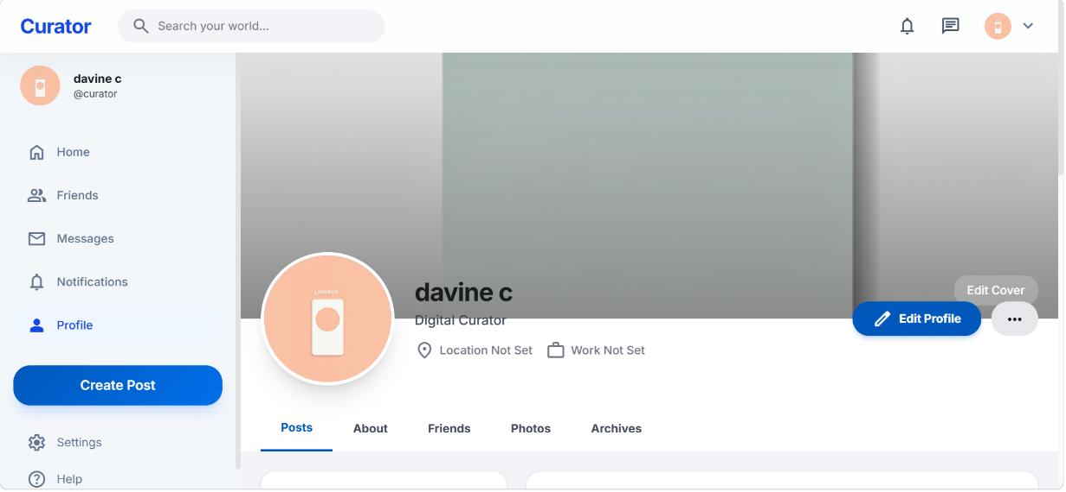
This is where the users can create and update profiles.
Includes profile picture, bio, and personal information.
3. Create and Manage Posts
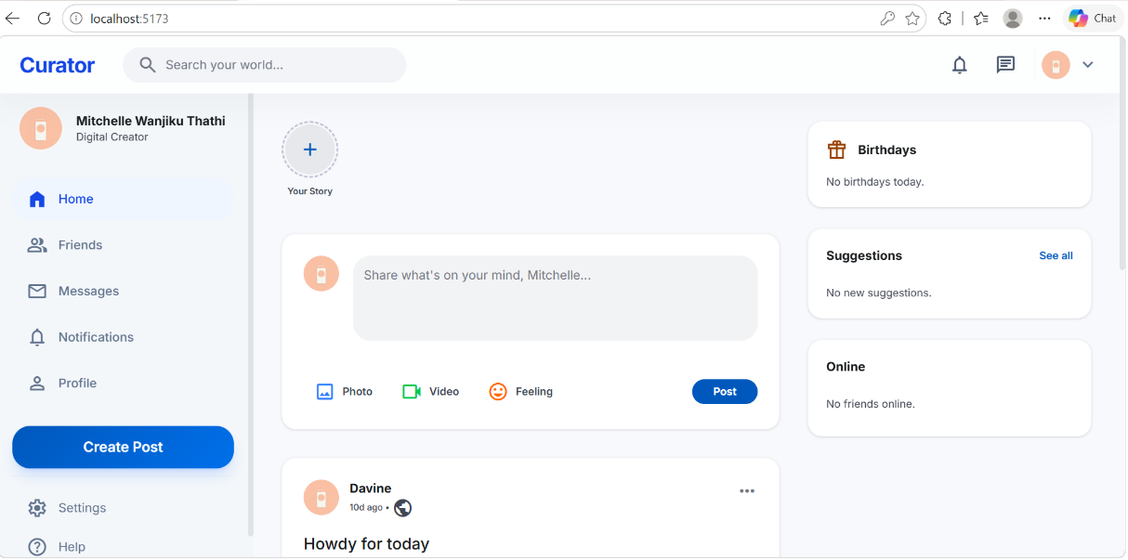
Users can upload text, images, or multimedia content.
Users can edit or delete their posts.

4. Social Interaction
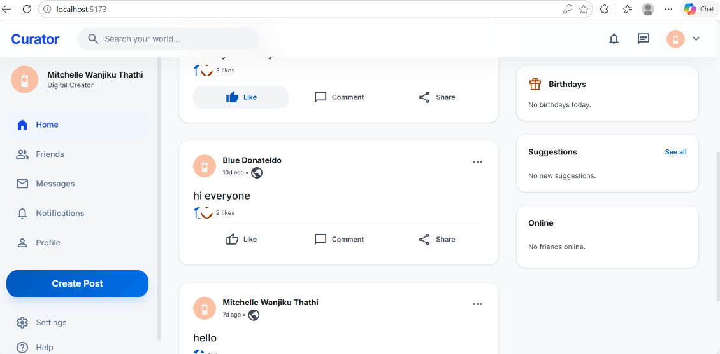
Like, comment, and share posts.
Follow/unfollow other users.
5. Messaging System
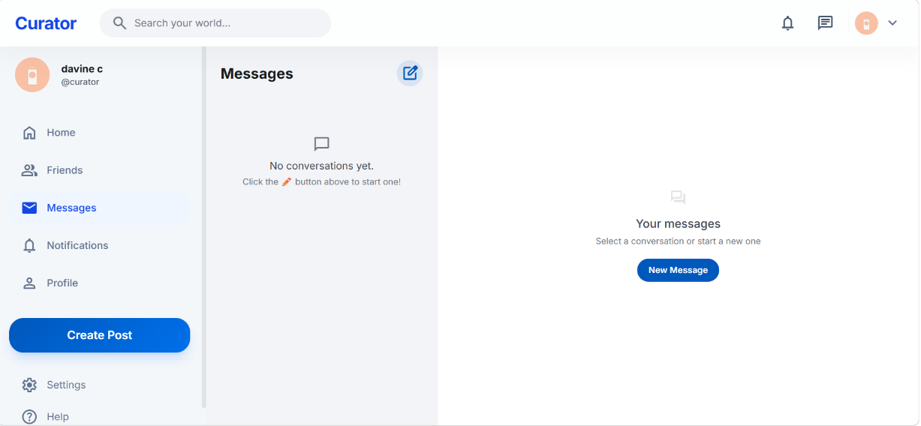
Users can send and receive private messages.
Real-time or near real-time communication.

6. Notifications
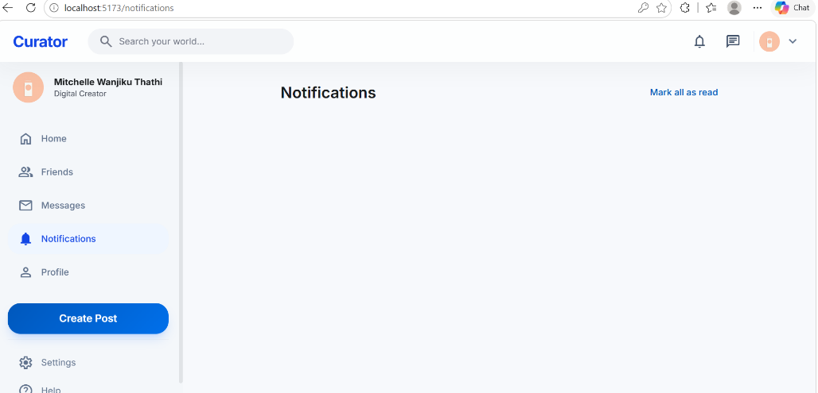
Users receive alerts for likes, comments, and messages.

2: Constraints and Analysis
1. Functional Constraints
-The system supports multiple users simultaneously.
-Data consistency is maintained across interactions.
-Real-time features are responsive.
2. Non-Functional Constraints
It has good performance-Fast response time for user actions.
Minimal delay in loading posts and messages.
Good Security-Protect user data (passwords, messages).
Prevent unauthorized access.
Usability-Simple and natural user interface.
3. Technical Constraints
Limited server resources (CPU, memory).
Network bandwidth limitations.
Database storage capacity.
4. Assumptions
The User has to have internet access.
Moderate traffic initially.
System will grow over time.
5. Analysis Summary
The system must balance performance, security, and scalability while providing a smooth user experience.

3: Basic Design
1. Architecture
The system follows a client-server architecture:
Frontend (Client): Type script
Backend (Server): node. js
Database: Stores user data and content
2. Components
Frontend
Displays posts, profiles, and notifications.
Sends user actions to backend.
Backend
Processes requests.
Handles authentication and business logic.
Database
Stores:Users,Posts,Comments and Messages
3. Data Flow
User logs in
Request sent to server
Server validates user
Data retrieved/stored in database
Response sent back to user
4. API Design
RESTful APIs:
/login
/register
/posts
/messages
5. Design Approach
Modular design for flexibility
Separation of concerns
Scalable structure for future growth

4: Bottlenecks Identification
As the system grows, several bottlenecks may arise:
1. Database Bottlenecks
Slow queries due to large datasets.
High read/write operations.
2. Server Overload
Too many concurrent users.
Increased API request traffic.
3. Network Latency
Delays in loading content.
Slow messaging delivery.
4. Media Storage Issues
Large images/videos consume storage.
Slow upload/download speeds.
5. Real-Time Communication Limits
Messaging systems may lag under heavy load.
Impact of Bottlenecks
Poor user experience
Increased response time
Possible system crashes
5: Scalability
First Iteration
To address initial bottlenecks:
1. Database Optimization
Indexing frequently queried data
You can use NoSQL databases for flexibility
2. Caching
Store frequently accessed data in cache (e.g., posts feed)
Reduces database load
3. Load Balancing
Distribute traffic across multiple servers
Prevent server overload
4. Content Delivery Network (CDN)
Store media files closer to users
Faster loading of images/videos
Results After First Iteration
Improved response time
Reduced server load
Better user experience
Second Iteration
As user base grows further:
1. Microservices Architecture
Break system into smaller services:
Authentication service
Post service
Messaging service
2. Horizontal Scaling
Add more servers instead of upgrading one
Handles increased traffic efficiently
3. Asynchronous Processing
Use queues for background tasks (notifications, emails)
4. Real-Time Technologies
This can be done by Implementing WebSockets for messaging
Faster communication
Remaining Bottlenecks
Data consistency across services
Increased system complexity
Solutions
Use distributed databases
Implement API gateways

Final Scalability & Conclusion
Final Optimized System
After iterations, the system includes:
- Load-balanced servers-this is where user requests are distributed across multiple servers instead of just one to prevent servers from overloading and improve speed and performance
- Optimized database
- Caching layer
- Microservices architecture to divide the application into independent services improving scalability, flexibility and fault isolation
- CDN (content delivery network) for media delivery like images and videos to users faster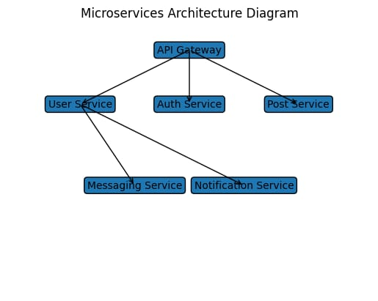

Conclusion
The Curator Social App project demonstrates how modern applications are designed and scaled to handle increasing user demands. By identifying bottlenecks and applying iterative improvements, the system evolves into a robust and efficient platform.
This report highlights that:
Good system design starts with clear use cases
Constraints must be carefully analyzed
Bottlenecks are inevitable but manageable
Scalability requires continuous improvement
If all this is followed then the final system is capable of supporting a large number of users while maintaining performance and reliability, making it suitable for real-world deployment.

